Experiment - 3

|  |  |
| --- | --- |
| **Student Name: Aditi R Sinha** | **UID: 22BCS15130** |
| Branch: BE-CSE  Semester: 6th  Subject Name: Java | **Section/Group: KRG 2B**  Date of Performance: 31/01/25  Subject Code: 22CSH-352 |

1. Aim: Develop a program for
   1. Easy Level: Square Root Calculation
   2. Medium Level: ATM Withdrawal System
   3. Hard Level: University Enrollment System
2. Implementation/Code:

a) import java.util.Scanner; public class SquareRootCalculator { public static void main(String[] args) {

Scanner scanner = new Scanner(System.in);

System.out.print("Enter a number: ");

try {

double num = scanner.nextDouble(); if (num < 0) { throw new IllegalArgumentException("Error: Cannot calculate the square root of a negative number.");

}

System.out.println("Square Root: " + Math.sqrt(num));

} catch (IllegalArgumentException e) {

System.out.println(e.getMessage());

} catch (Exception e) {

System.out.println("Error: Invalid input. Please enter a numeric value.");

} finally { scanner.close();

}

}

b) import java.util.Scanner;

class InvalidPinException extends Exception { public InvalidPinException(String message) { super(message);

}

}

class InsufficientBalanceException extends Exception { public InsufficientBalanceException(String message) { super(message);

}

}

public class ATM { private static final int PIN = 1234; private static double balance = 3000.0;

public static void main(String[] args) { Scanner scanner = new Scanner(System.in);

try {

System.out.print("Enter PIN: "); int enteredPin = scanner.nextInt(); if (enteredPin != PIN) { throw new InvalidPinException("Error: Invalid PIN.");

}

System.out.print("Withdraw Amount: "); double withdrawAmount = scanner.nextDouble();

if (withdrawAmount > balance) {

throw new InsufficientBalanceException("Error: Insufficient balance. Current Balance: " + balance);

}

balance -= withdrawAmount;

System.out.println("Withdrawal successful! Remaining Balance: " + balance);

} catch (InvalidPinException | InsufficientBalanceException e) {

System.out.println(e.getMessage());

} catch (Exception e) {

System.out.println("Error: Invalid input.");

} finally {

System.out.println("Final Balance: " + balance); scanner.close();

}

}

c)

import java.util.HashMap; import java.util.Scanner;

class CourseFullException extends Exception { public CourseFullException(String message) { super(message);

}

}

class PrerequisiteNotMetException extends Exception { public PrerequisiteNotMetException(String message) { super(message);

}

}

public class UniversityEnrollment { private static final int MAX_ENROLLMENT = 2; private static HashMap<String, Integer> courseEnrollments = new HashMap<>(); private static HashMap<String, String> prerequisites = new HashMap<>();

public static void main(String[] args) { // Defining course prerequisites prerequisites.put("Advanced Java", "Core Java"); prerequisites.put("Machine Learning", "Mathematics");

Scanner scanner = new Scanner(System.in);

try {

System.out.print("Enroll in Course: ");

String course = scanner.nextLine();

System.out.print("Prerequisite: ");

String prerequisite = scanner.nextLine();

if (prerequisites.containsKey(course) && !prerequisites.get(course).equals(prerequisite)) { throw new PrerequisiteNotMetException("Error: PrerequisiteNotMetException - Complete " + prerequisites.get(course) + " before enrolling in " + course + ".");

}

int enrolledCount = courseEnrollments.getOrDefault(course, 0); if (enrolledCount >= MAX_ENROLLMENT) { throw new CourseFullException("Error: CourseFullException - The course is full.");

}

courseEnrollments.put(course, enrolledCount + 1);

System.out.println("Enrollment successful for " + course + ".");

} catch (PrerequisiteNotMetException | CourseFullException e) {

System.out.println(e.getMessage());

} finally { scanner.close();

}

}

}

3. Output:

**(a)**

(a)

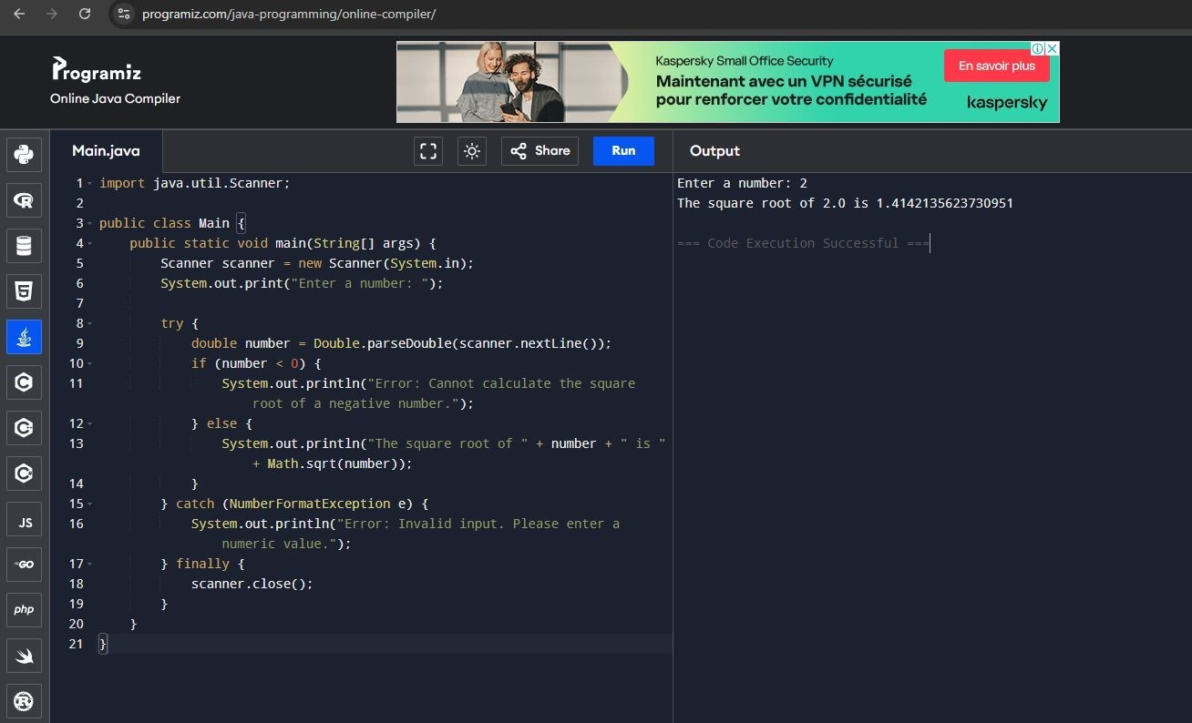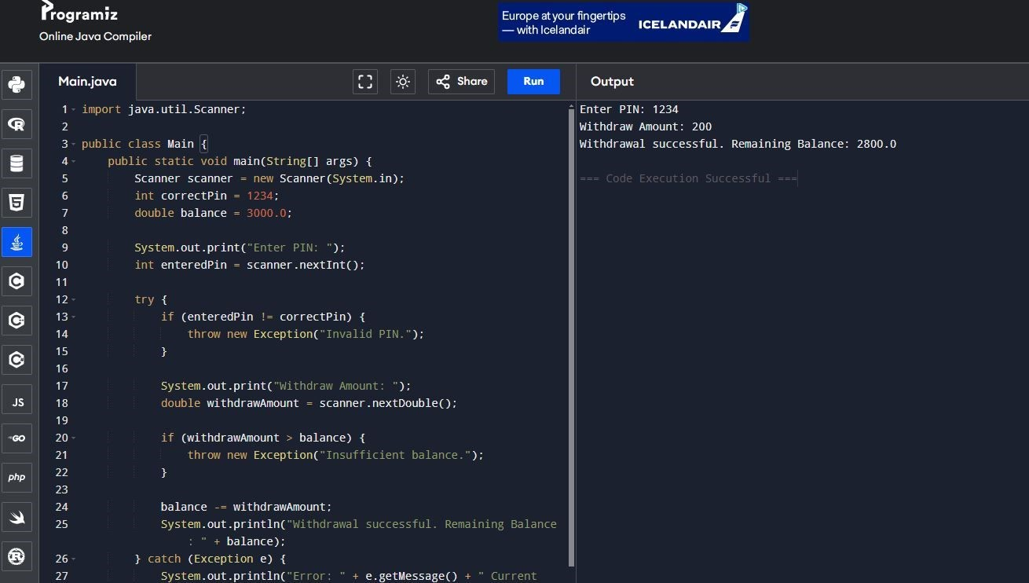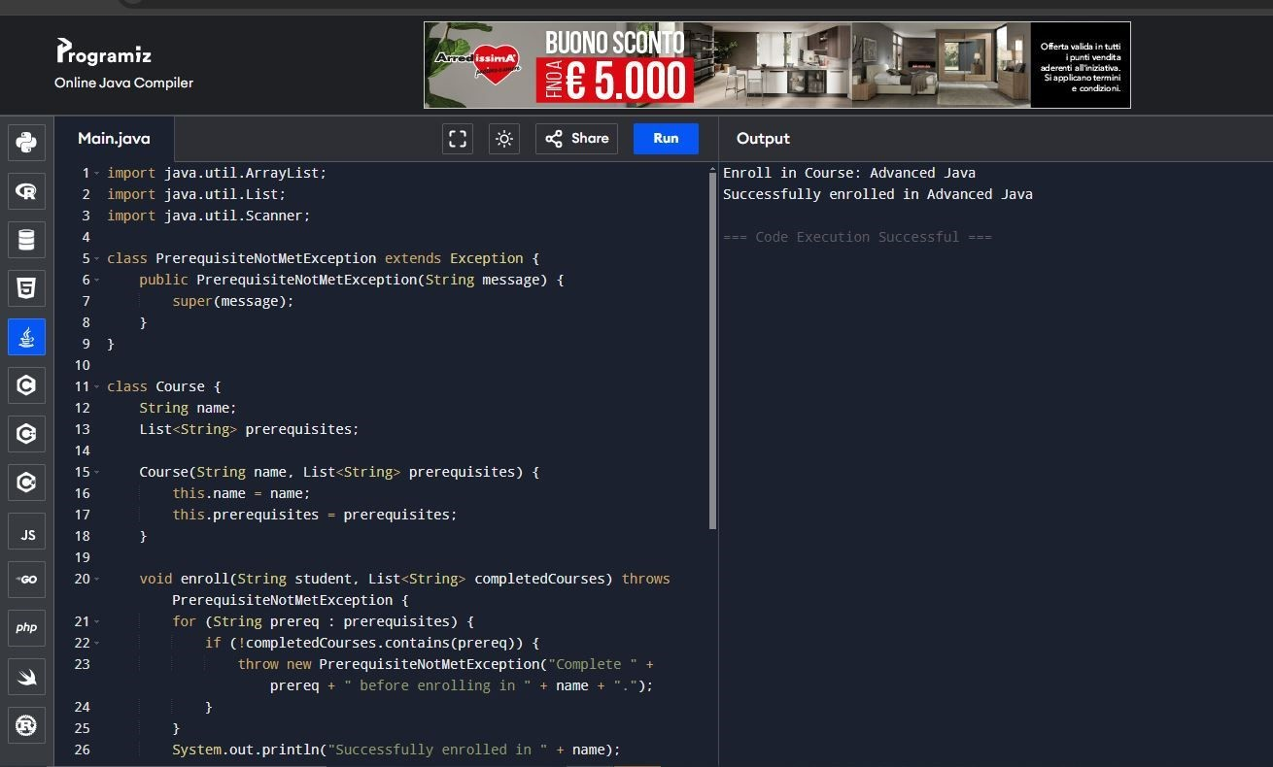

**(b) (c)**

6. Learning Outcomes:

* Exception Handling & Robust Code – Learn to use try-catch, throw, and custom exceptions for handling errors like invalid input, insufficient balance, and unmet prerequisites.
* User Input & Decision Making – Gain experience in handling user inputs, validating conditions (PIN check, balance check, prerequisites), and controlling program flow.
* OOP & Data Management – Understand object-oriented principles like custom exception classes and use data structures (e.g., HashMap) for managing enrollments dynamically.